EEE7408-01 (Medical Imaging Processing): Assignment 3 solution

Questions
1. Simple Gridding Reconstruction
Reconstruct an 128×128 image of the simulated phantom data with this algorithm. There is a dominant low frequency artifact. What is it due to? Display your reconstruction.

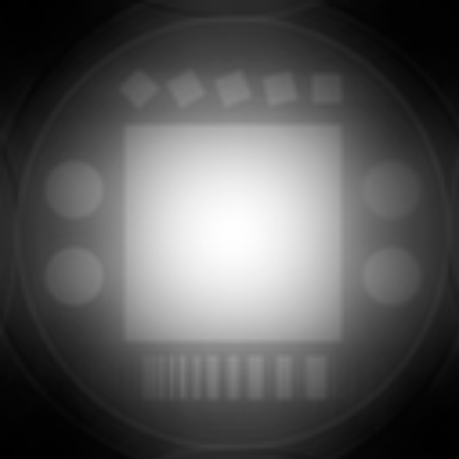
>> The simple gridding reconstruction produces the image shown in Fig. 1. The dominant DC artifact is due to the fact that the spiral trajectory oversamples the low spatial frequencies, and we haven’t compensated for that fact, yet.
Figure 1: Simple 1X gridding reconstruction. The predominant low frequency artifact is due to oversampling of the low spatial frequencies by the spiral acquisition.

2. Pre-weighted Gridding Reconstruction
Extend the algorithm to use the preweighting function w that has been provided. Display your reconstruction.

>> Preweighting the data by the provided density estimate produces the image shown in Fig. 2.
The low frequency artifacts are suppressed, by aliasing artifacts are still quite prevelant.
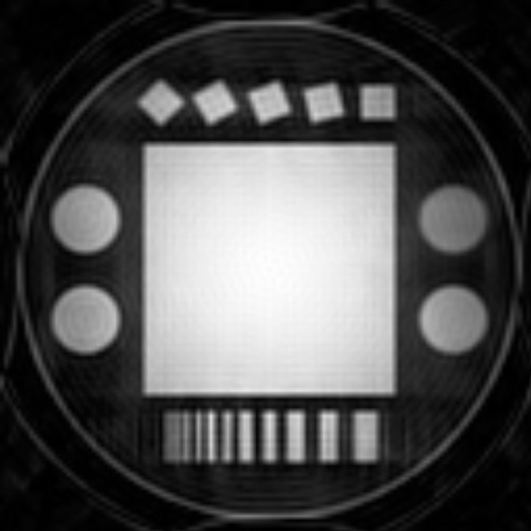
Figure 2: Simple gridding reconstruction with density precompensation. The low-frequency artifact has been corrected, but significant aliasing is apparent.

3. Oversampled Gridding Reconstruction
Extend the algorithm to reconstruct on a 2X grid. This is a grid that is sampled twice as finely in k-space, and has twice the FOV in image space. The kernel should extend for ±2 samples on the 2X grid. Display your 2X reconstruction. What artifacts have been reduced or eliminated?

>> Extending the reconstruction to a 2X grid, we get the reconstruction shown in Fig. 3. The main problem people had here was not scaling the triangular kernel for the 2X FOV. The kernel should have the same width in spatial frequency as in the 1X case. That means the width has twice as many samples as in the 1X case. The most notable effect of using a kernel that is twice too small shows up in the next part. A very small kernel is essentially an impulse, and hence needs no deapodization correction. This also will allow more aliased energy from the sidelobes. However, even a poor kernel on a 2X grid works well, so the differences are not that apparent from this example.
The specific changes are in the part of grid1.m that computes the triangular kernel

% compute weighting for triangular kernel
kwx = max(1-abs(nx-nxt),0);
kwy = max(1-abs(ny-nyt),0);

This should to be replaced with

% compute weighting for triangular kernel on 2X grid
kwx = max(1-0.5*abs(nx-nxt),0);
kwy = max(1-0.5*abs(ny-nyt),0);

so that the kernel extends ± 2 samples on the 2X grid.
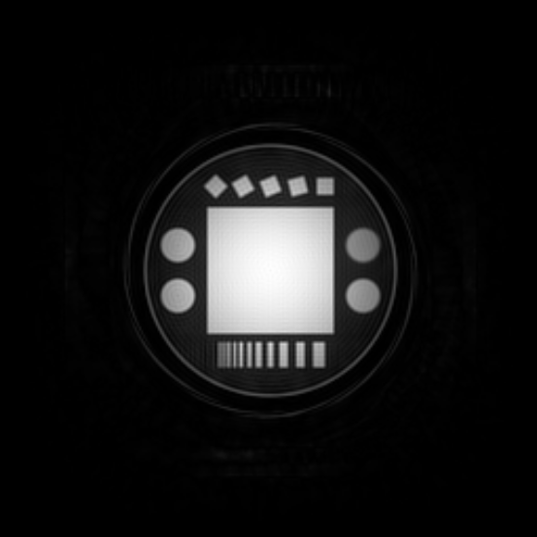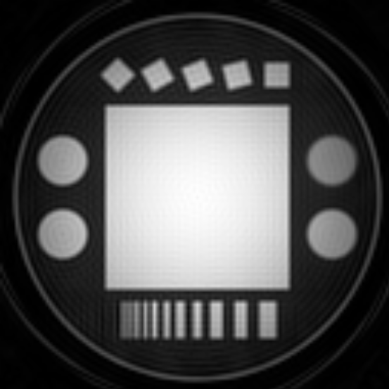
Figure 3: Reconstruction using a 2X grid, showing the full 2X reconstruction FOV (left) and the central 1X FOV (right). The aliasing artifacts have been significantly suppressed.

4. Deapodization Correction
The kernel we are using is a separable triangle function in kx and ky. Compute the apodization produced by this kernel for the 2X oversampled reconstruction, and divide it out of the reconstructed image. Plot a cross-section through the phantom before and after correction. Display your corrected reconstruction.

>> The first point to note is that since we are using a 2X grid, there isn’t a tremendous amount of apodization to correct. There are several alternatives for computing the deapodization function. Since the kernel is separable, we’ll just consider the x axis. The kernel is a triangle function in k-space. The apodization function is then the transform of the triangle Λ(kx/Δkx), which is a sinc²(x/FOV) in each axis. Another alternative is to consider the values of the sampled triangle kernel, and explicitly compute its transform. A triangle centered on DC has only three non-zeros samples, a delta at the origin, and two deltas of amplitude 0.5 at ± one k-space sample on the 2X grid,
C(kx) = 0.5δ(kx/2Δkx + 1) + δ(kx/2Δkx) + 0.5δ(kx/2Δkx − 1).
The Fourier transform of this is
c(x) = 1 + cos(πx/FOV ).
This could just as easily be computed numerically with a DFT. Images comparing these deapodization functions are shown in Fig. 4, and cross-sectional plots through the middle of the phantom in Fig. 5. The sinc²(x/FOV ) deapodization is quite acccurate. The (1+cos(πx/FOV )) deapodization function is close, but leaves a little apodization uncorrected.
If you used a kernel that was too small (a common problem), your cross section plots will be quite flat even before deapodization. In this case, applying a deapodization function will cause the edges of the image to be enhanced.
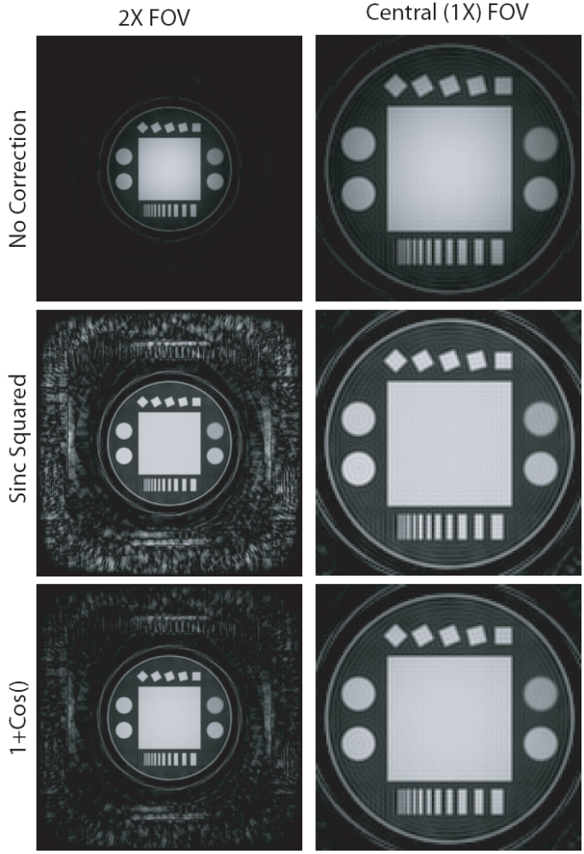
Fig .4
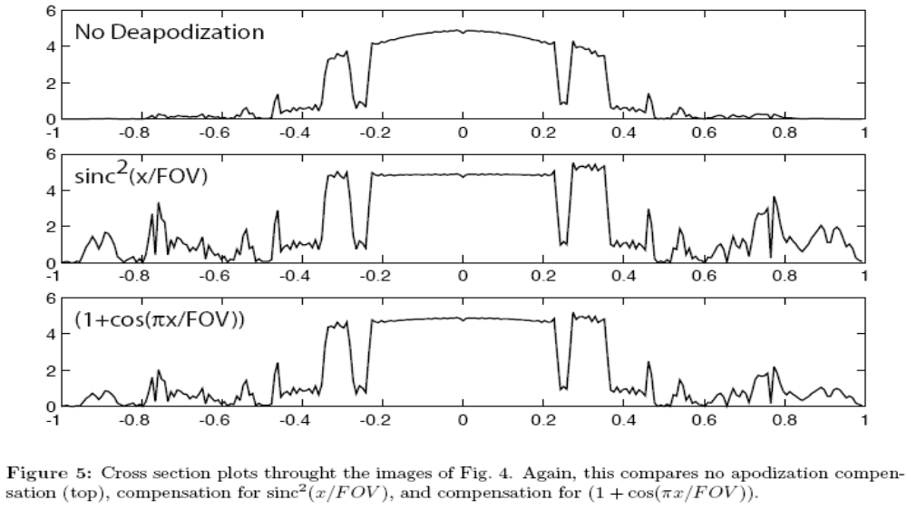
Figure 5: Cross section plots throught the images of Fig. 4. Again, this compares no apodization compensation (top), compensation for sinc²(x/FOV), and compensation for (1 + cos(πx/FOV )).

5. Improved Kernel
Many kernels work well on a 2X grid. One of the most widely used kernels is the Kaiser-Bessel window. It’s shape is dependent on a single parameter β, which makes it easy to describe. Also, there is an analytic expression for the inverse transform that is required for the deapodization function. Modify your gridding routine to use the Kaiser-Bessel kernel, given a value of β, and a kernel width. Use the expressions from the Beatty paper.
Reconstruct the data set rt_spiral_03.mat. Fully correct for apodization based on the analytic expression in the paper. Assume a width of 5 grid samples on the 2X grid, and choose the optimal value of β from Eq. 5 of the paper (which is listed in Table III). As a reality check, the kernel should look like Fig. 6. The function I₀(x) used in computing the kernel is the zero order modified Bessel function of the first kind, and is implemented in matlab as besseli(0, x).
You will want to pre-compute the kernel. Assume that we will allow the maximum error due to kernel sampling to be 10⁻³, choose either nearest neighbor or linear interpolation for the kernel, and choose an appropriate kernel sampling density.
Display images of the full 2X FOV, and the central 1X FOV that would normally be displayed. Also, plot a cross section through the middle of the phantom to demonstrate that the deapodization is correct.

>> We first need to compute the kernel. The optimum β for the Kaiser-Bessel kernel is 11.44, using the expressions from the Beatty paper. The result is plotted in Fig. 6, which was given in the assignment.
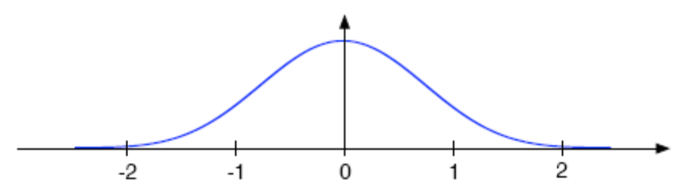
Figure 6: Optimum Kaiser-Bessel Kernel for a 2X grid, with a kernel width of 5 samples on the 2X grid.

I used nearest neighbor interpolation for the kernel, with an oversampling factor of 455. This results in a reasonable length array to look the kernel samples up from, and a simple implementation. A kernel oversampling factor of only 10 would be sufficient for linear interpolation, but the implementation would be more complex. A final alternative is simply to compute the kernel for each sample. This would be slower.
The only difficulty in the implementation is to make sure that the loops over the kernel samples has the proper ranges. It should go from +/− half the kernel width on the 2X grid.
The reconstruction for the 2X FOV, and the central 1X FOV shown in Figs. 7. The cross section through the image is shown Fig. 9, showing that the apodization has been accurately corrected.
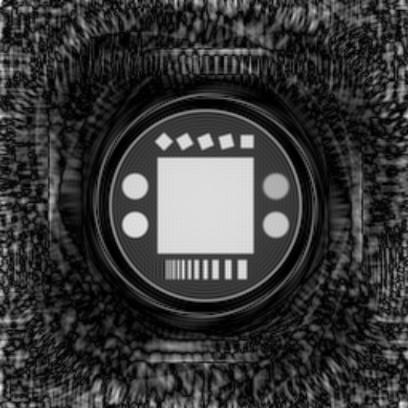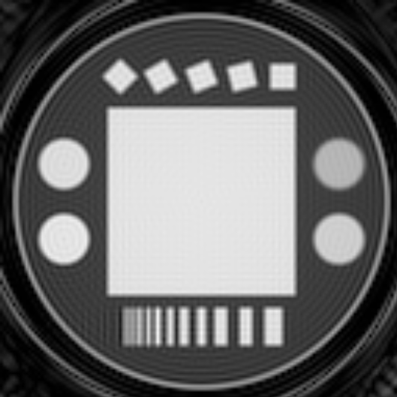
Figure 7: Reconstruction using the optimum Kaiser-Bessel kernel on a 2x grid, using a 5 sample kernel (on the 2X grid)

6. Non-Integer Oversampling
Modify your gridding routine to reconstruct at non-integer oversampling factors. Use an oversampling ratio of 1.25, and choose a kernel size to achieve a reconstruction error of 10⁻³. Find the optimum β for the Kaiser-Bessel kernel. Use an interpolation method for the kernel to give you a 10⁻³ maximum error.
Recontruct the data set rt_spiral_03.mat. Fully compensate for apodization using the analytic expression. Show images of the 1.25X FOV, the central FOV that would normally be displayed, and plot a cross section to show that the deapodization is working correctly.
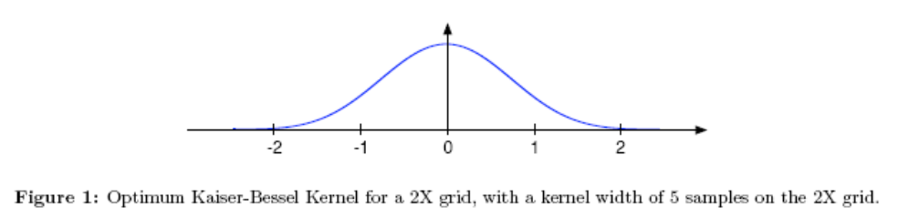
>> In order to obtain a maximum reconstruction error of 10⁻³, we need a kernel width of 6 samples. This is from the plot in Fig. 3 of the Beatty paper. The optimum β can then be computed as 10.995. The kernel oversampling factor for nearest neighbor interpolation, and 10⁻³ maximum error and 1.25X oversampling is 728. This still results in a reasonable length array, so I didn’t go to linear interpolation, which would reduce the kernel oversampling to 16.
The reconstruction of the full 1.25X FOV and the central 1X FOV are shown in Fig. 8. A cross section is plotted in Fig. 9 showing the apodization correction is working properly, and that the profile is essentially identical to that of the 2X reconstruction. A difference image multiplied by 5000 is also shown. A constant scale factor of 0.66624 has been applied to the 1.25X reconstruction to correct for the different kernel areas.
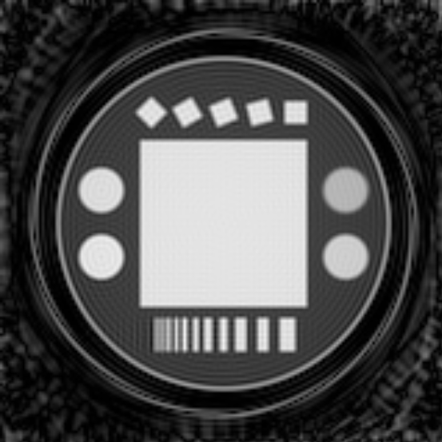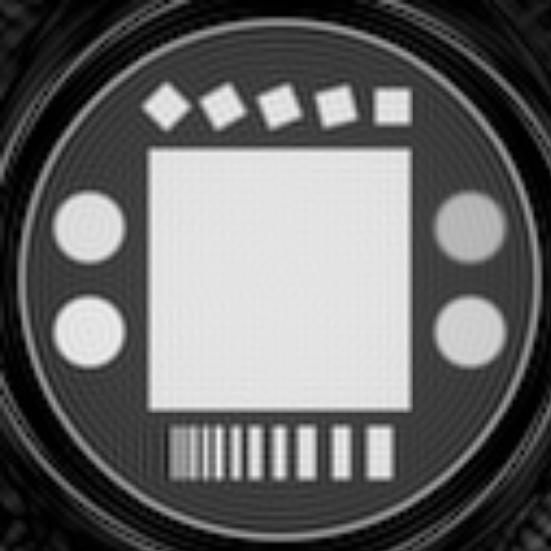
Figure 8: Reconstruction using the optimum Kaiser-Bessel kernel on a 1.25x grid, using a 6 sample kernel
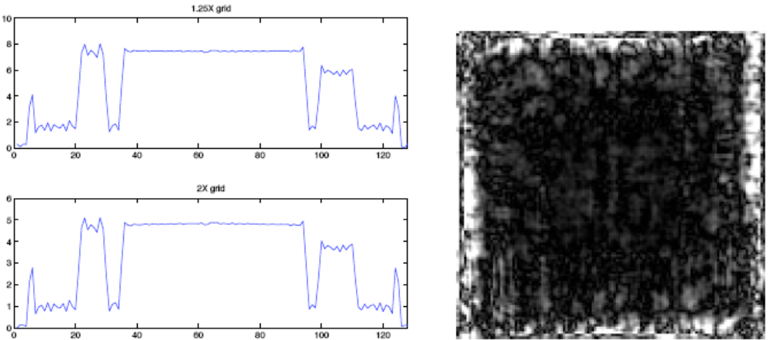
Figure 9: Cross sections through the central 1X FOV of the 2X and 1.25X reconstructions. The two plots are essentially identical. A difference image multiplied by 5000 is shown on the right.

